Adverse reaction to transfusion

[Author Name(s), First M. Last, Omit Titles and Degrees]

[Institutional Affiliation(s)]

Contents

Adverse Reaction to transfusion 3

1. Introduction 3

2. Clinical transfusion procedure and practice 5

2.1 Principles and practices of transfusion 6

2.2 Procedures 7

Indications 7

Blood requirement 8

2.3 Adverse reaction of transfusion of blood and blood products 9

2.4 Issues in blood transfusion 12

Conclusion 14

References 15

# Adverse Reaction to transfusion

# 1. Introduction

Transfusion in medical is stated as the transfer of body parts or blood to another for various different purposes. The transfusion of blood is more linked by the rising rate of morbimortality that has been more commonly occurred in the surgical process. The transfusion of blood is more commonly required in hepatic resection, cardiac surgeries, transplantation of the liver, and other major diseases. During surgery as to avoid any risk for instance low red blood cells in the human body and other survival problems, the transfusion of red blood cells or platelet has become the reason for survival. Meanwhile, the transfer of red blood cells is also becoming a cause of cancer and aids just because of that the blood is a transferred from one body to another. One person is affected by any serious disease related to blood and transferring blood to another person will become a cause death (Gordon et al, 2021). Transfusion of blood or any other body part is the most common in today’s medical and health practices. The availability of blood and blood products donors has saved the life of many serious patients all around the world. With the advancement of science and technology, the medical process and procedures become more advanced and flexible.

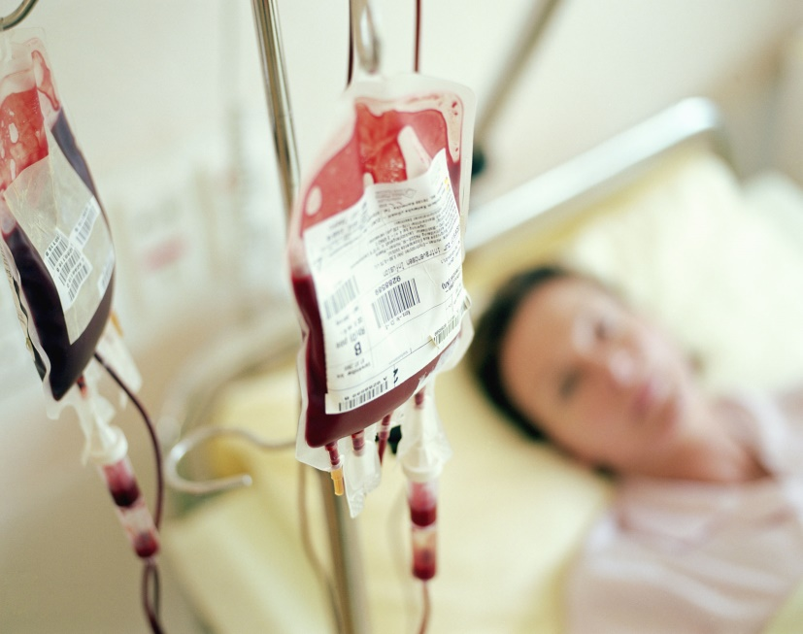

Figure 1: blood transfusion

Doctors and medical staff during surgery with the help of advanced technology and medical devices are more aware of changing human body motions and conditions. Furthermore, when blood levels and red blood cells become decline during surgery, the surgeons are more looking towards blood transfusion to save the life of patients. The National Institute of Health (2015) stated that red blood cell in a body performs a fundamental role in transporting oxygen in the entire body. During many complex surgeries, the red blood cells become decreased in the body which directly affected the patient’s oxygen level. When the oxygen level becomes declined the chances of survival have become more less. The transfusion of blood is more commonly required after complex surgeries and loss of red blood cells in human body. The United States of America medical institutes and research declared that cells are stored for almost 42 days while the average transfusion time is 18 days.

# 2. Clinical transfusion procedure and practice

In all over the world, transfusion of blood during and after surgery is a common practice in many hospitals and clinics. Meanwhile, medical staffs and surgeons follow significant procedures and guidelines of the World health organization (WHO) while transferring blood or red blood cell in the human body as to considering risk (Bediako, Ofosu-Poku & Druye, 2021). In many cases, transfusion of blood that contains an error such as transfer blood of infected people to patients will lead to complexities with respect to mortality. Hazzazi, Wijesekera & Hindawi (2014), illustrated that with advancement in medical industry, the methods of transfusion of blood have been improved in various hospitals and clinics. Moreover, the blood banks are also improving their procedures as to test the donated blood on labs before transferring it to required patients. The blood transfusion process is indicated when the blood donor donated blood for transfusion in first phase the blood is been checked in right container, further identify the right patient who urgently required blood, check blood information of patients and their allergies, transfuse blood when all criteria are significantly matched.

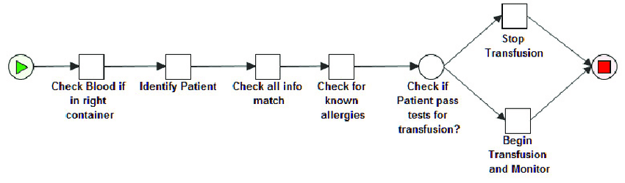

Figure 2: blood transfusion process

## 2.1 Principles and practices of transfusion

* During complex surgeries, patients lose a lot of blood and red blood cells which directly affected oxygen levels in human body that is an alarming signal to a lost life. Moreover, the patients who lost their red blood cells during surgeries should be provided replacements of fluids, oxygen through advanced airway technological devices, and other effective medical treatments in clinics or hospitals in the form of transfusion.
* For patients who are suffering from hemoglobin, before transfusion of blood, the value of hemoglobin is more important to consider. It should be important to consider all the factors before transfusion of blood, the transfusion required appropriate symptoms and other clinical signs to avoid risks and issues of mortality.
* Clinics and their medical staff should be more informed and aware of the risks and after-effects of transfusion of blood.
* Transfusion of blood and blood products should be prescribed.
* Recordkeeping of data and information in clinics related to the transfusion of blood with all ordering purposes.
* Doctors and medical staff should be trained to deal with complex cases and transfusion of blood.

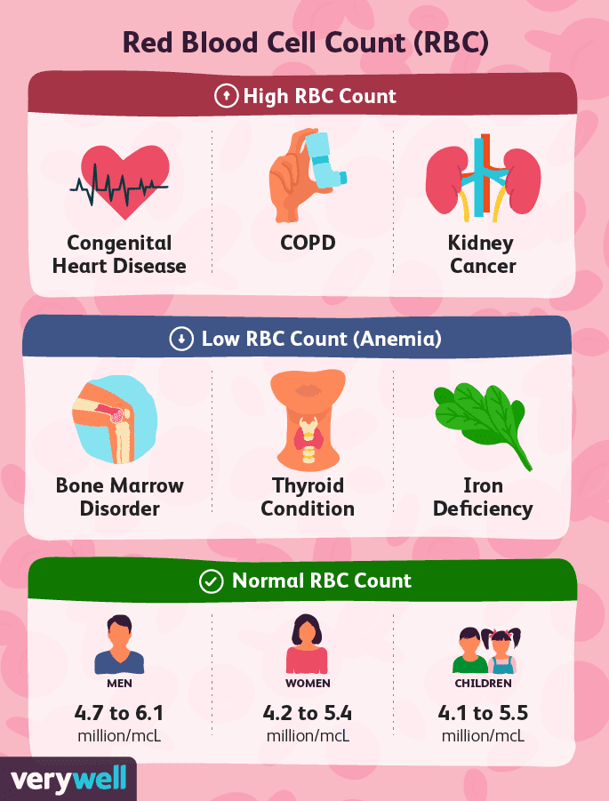

Figure 3: RBC Count

## 2.2 Procedures

### Indications

The significant indications of transfusion of blood and blood products are stated as:

* To enhance the capacity and level of oxygen by transfusion of red blood cells.
* Restoration of blood to stabilize the volume of blood for maintaining and controlling tissue perfusion.
* Replacement of platelets, plasma protein, and other factors.

### Blood requirement

In certain complex and serious cases, blood is required by human body for effective survival. The blood is required in certain specific situations included as loss of blood through high bleeding and trauma, thalassemia patients and leukemia patients, loss of blood cells through other diseases (Sadana et al., 2021).

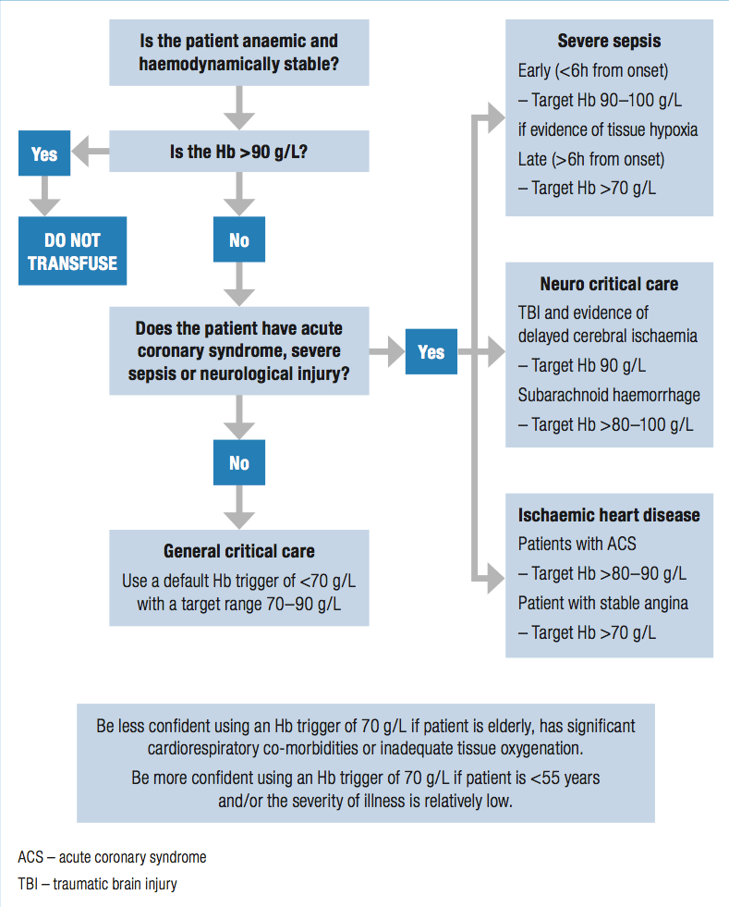

Figure 4: Transfusion in critical cases

## 2.3 Adverse reaction of transfusion of blood and blood products

During transfusion of blood, blood products, and platelets it is more important to be a concerned the safety practices. In most cases, the transfusion has become more risker to a patient’s life when the transferable blood is not tested in labs or patients are not properly checked before transfusion. It is observed in most cases that when transfer platelets the rate of reaction among patients is higher. Data of hemovigilance module by national health care safety network illustrates that receiver of apheresis platelets have an adverse reaction during and after transfusion. The rate of adverse reaction is 1 lac components transfused per number. Products related to high plasma volume are containing an adverse reaction included as acute hemolytic and lung injuries. The adverse transfusion reaction has been caused due to mediated responses of immune which is recipient to antibodies that presented in plasma. The most common diseases and infection that have occurred after transfusion is HIV, hepatitis B, and hepatitis C (Mowla et al., 2021).



Figure 5: adverse reaction blood transfusion rate in US in 2015 and 2017 through different types

In the United States, risk of adverse reactions of transfusion that become a cause of HIV, hepatitis B, and C are declined due to concerning specific principles and practices in hospitals. Despite of this, in platelets, bacterial contamination has become a major risk for the safety of the recipient. Transfusion of blood and other blood products are more commonly create many adverse reactions in various types per 1 lac components transfused. The transfusion of blood and other body parts more commonly occurs in United States during complex surgeries and other diseases. Figure 5 represents multiple adverse reactions with a rate in 2015 and 2017 included as febrile 118.1 and 120.5, allergic reaction 85.3 and 88.4, hemolytic reaction 4.5 and 4.8, dyspnea 7.5 and 6.5, lung infection 1.7 and 1.5, and many other infections. The rate of mentioned adverse reaction and infection is high in United States as compared to other minor reactions such as bacterial viral infection, and other viral transmitted infections. Soodejani et al (2020), transfusion of blood through donors is a significant component that saves many lives all around the world on annual basis. It has been observed that approximately 30% of overall world population are the receptor of the blood of their whole life. The donation of blood is associated with low risk but the adverse reaction during and after transfusion has restricted donors and patients to not donating or receiving blood again.

Patients deal with various serious infections after transferring of blood from one person to another such as human immunodeficiency virus, hepatitis B and C, and aids. Many clinics and hospitals are not carried out transfusion guidelines and principles before transferring blood and blood products in patients, although this causes an adverse reaction in terms of local and systematic reactions. More commonly the adverse reaction is been classified into local reactions and systematic reactions: (i) local adverse reaction is classified as hematoma, bruising, inflammation; (ii) systematic adverse reactions are categorized through hyperventilation, bruising, hyperventilation and pallor. The other factors which become a cause of adverse reaction of transfusion are donor's sexual distribution and other forms of donations. Kracalik, Mowla, Basavaraju & Sapiano (2021) discussed the blood transfusion adverse reaction in different facilities in the years between 2013 to 2018, while in 201 facilities the data shows adverse reactions in 18, 308 transfusions, although it has occurred in 8.3 million components of blood. Therefore in apheresis, platelets and RBC reaction is reported as higher per 100,000 components. Furthermore, one out of all blood components, during and after transfusion has a riskier reaction that becomes the cause of infections. According to the research of medical science, some adverse reactions are beneficial when they rely on safety and preventable measures.

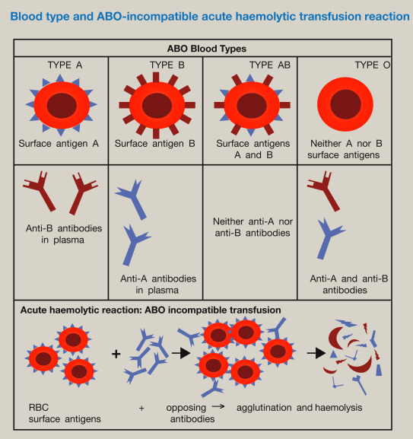

Figure 6: risk of blood transfusion

## 2.4 Issues in blood transfusion

Thalassemia is one of the serious diseases which required excessive required of blood on regular basis. The rates of blood transfusion in thalassemia patients are much higher as compared to other patients. Shah et al (2019), determined that in countries like South Africa, the Mediterranean, and Southeast Asia, the cases of thalassemia patients more commonly occur. All across the world, it is determined that the people who are suffering from this serious disease of thalassemia are dealing with several issues included as regular access to safe and required blood quantity, although the safe transfusion of blood is the main priority. The issues and challenges arise when thalassemia patients get lack access to blood donors, lack awareness of thalassemia, transfuse non-tested blood, poor blood transfusion policies, and procedures, an insignificant gap of supply, and demand of blood. In South African countries people get poor medical services, for instance, inadequate testing of antigen. The risk of blood transfusion adverse reaction and infections are higher in thalassemia patients just because of not a proper screening of blood and safety procedures are applied in clinics/hospitals. With an increasing number of cases of adverse reactions included as bacterial infection, febrile, allergic reaction, hemolytic reaction, dyspnea, lung infections, etc. thalassemia patients are avoiding the practices of transfusion of blood and suffering from poor health which resulting in loss of lives.

Transfusion of blood and other blood product is beneficial because of its saves millions of lives every day around the world but risk of adverse reaction is also associated with it. In many countries due to transfusion of blood people have to deal with many serious diseases which become a major cause of death. Due to lack of awareness or to save life of people, the donors who are affected with HIV or other blood-related diseases were impacted by other receptors through transfusions. The reactions of transfusion during and after surgery or in thalassemia are not always serious but sometimes it becomes life-threatening such as affected patient’s kidney, anemia, affected lungs which become a cause of respiratory problems, and inadequate blood circulation in the human body Nall (2018). Science and technology are continuously striving for giving an adequate solution to medical and health sectors through research and development process. The medical institutes have formed fundamental guidelines and practices to decrease the risk of transfusion. Papaioannou et al (2019), the safety in transfusion of blood or any other part of human body is more essential for patients who are suffering from serious and complex diseases. Moreover, clinics and hospitals while consider appropriate transfusions guidelines and practices to secure and protect patient’s life. Furthermore, with the help of technology, medical practices are more advanced to re-engineered artificial blood, and blood vessels are properly tested in labs before being transfused. The other benefit of blood transfusion is to mitigate the risk of adverse reactions and reduce the unavailability of blood in critical times. It is more beneficial for thalassemia patients who required blood or blood donors on a regular basis.

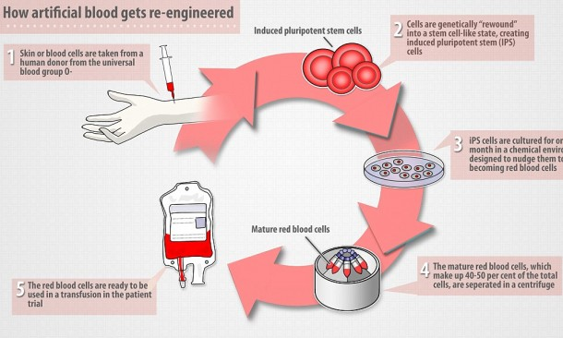

Figure 7: artificial blood reengineering

# Conclusion

The donation of blood and other body parts through transfusion is performing a significant role in saving millions or billions of lives. The patients in ICUs and emergency are urgently required blood donors or blood bags due to loss of red blood cells during complex surgeries, operations, and any other critical surgeries. Transfusion is the most common practice in clinics and hospitals while it required considering certain specific guidelines and indications to avoid risk of infections and adverse reactions. The National Institute of Health stated that red blood cell in a body performs a fundamental role in transporting oxygen in the entire body. During many complex surgeries, the red blood cells become decreased in the body which directly affected the patient’s oxygen level. Moreover to avoid risk clinics and their medical staff should be more informed and aware of the risks and after-effects of transfusion of blood and transfusion of blood and blood products should be prescribed

# References

Gordon, K., Figueira, E. R. R., Rocha-Filho, J. A., Mondadori, L. A., Joaquim, E. H. G., Seda-Neto, J., ... & D'Alburquerque, L. A. C. (2021). Perioperative blood transfusion decreases long-term survival in pediatric living donor liver transplantation. *World journal of gastroenterology*, *27*(12), 1161.[www.nih.gov/news-events/nih-research-matters/storing-blood-transfusion](http://www.nih.gov/news-events/nih-research-matters/storing-blood-transfusion)

Bediako, A. A., Ofosu-Poku, R., & Druye, A. A. (2021). Safe Blood Transfusion Practices among Nurses in a Major Referral Center in Ghana. *Advances in Hematology*, *2021*.

Hazzazi, N., Wijesekera, D., & Hindawi, S. (2014). Formalizing and verifying workflows used in blood banks. *Procedia Technology*, *16*, 1271-1280.

Sadana, D., Kummangal, B., Moghekar, A., Banerjee, K., Kaur, S., Balasubramanian, S., ... & Krishnan, S. (2021). Adherence to blood product transfusion guidelines—An observational study of the current transfusion practice in a medical intensive care unit. *Transfusion Medicine*, *31*(4), 227-235.

Kracalik, I., Mowla, S., Basavaraju, S. V., & Sapiano, M. R. (2021). Transfusion‐related adverse reactions: Data from the National Healthcare Safety Network Hemovigilance Module—the United States, 2013–2018. *Transfusion*, *61*(5), 1424-1434.

Soodejani, M. T., Haghdoost, A. A., Okhovati, M., Zolala, F., Baneshi, M. R., Sedaghat, A., & Tabatabaei, S. M. (2020). Incidence of adverse reaction in blood donation: a systematic review. *American Journal of Blood Research*, *10*(5), 145.

Mowla, S. J., Kracalik, I. T., Sapiano, M. R., O'Hearn, L., Andrzejewski Jr, C., & Basavaraju, S. V. (2021). A comparison of transfusion-related adverse reactions among apheresis platelets, whole blood-derived platelets, and platelets subjected to pathogen reduction technology as reported to the National Healthcare Safety Network Hemovigilance Module. *Transfusion medicine reviews*, *35*(2), 78-84.

Shah, F. T., Sayani, F., Trompeter, S., Drasar, E., & Piga, A. (2019). Challenges of blood transfusions in β-thalassemia. *Blood reviews*, *37*, 100588.

Nall, R., (2018). Transfusion reaction.  *Healthline.*

Papaioannou, T. G., Manolesou, D., Dimakakos, E., Tsoucalas, G., Vavuranakis, M., & Tousoulis, D. (2019). 3D bioprinting methods and techniques: applications on artificial blood vessel fabrication. *Acta Cardiologica Sinica*, *35*(3), 284.